Step 0 Intake + Interview Filing Status, Dependency

Interview Notes: (See also: General Notes)
- Shirley worked part time to earn spending money.
- Shirley is single and living with her parents while she attends college full time.
- Shirley is totally supported by her parents and her parents will claim her as a dependent on their return.

Documents:
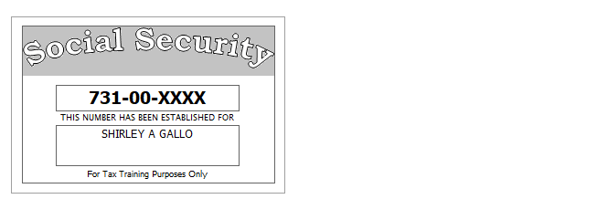

Step 1 Basic Information
TP Form / Note | TS Screen | Notes
SS Card | Start a New 2017 Tax Return  Available Taxpayer Profiles | Ignore the Profiles  Select “Enter Social Security Number” at the bottom of the screen  Enter the TP SSN twice and “Start Return”
 | Basic Information – Filing Status
SS Card  Intake Sheet  I-Notes 2,3 | Personal Information  Taxpayer Information  Address & Phone Number | Hint: Enter all information using “Caps Lock”  Hint: Use Name and SSN from SS card. (Not Intake Sheet)  Hint: SSN format YYY-00-0752  TS: Birth date can be entered using drop down menu or filling in the field.  TS: Check any of the “Check here” questions that apply:  - Claimed as a dependent on someone else’s return  - Over 18 and full time student  - TP wishes to contribute $3 to the Presidential Election Campaign Fund  TS: Enter Zip code- TaxSlayer fills in city and state. Correct if required  Hint: Did you enter the apt. number?  TS: Enter New Jersey as the Resident State  TS: Select Continue
Intake Sheet  G-Note 3 | New Jersey Return | Hint: Begin NJ Return  TS: Select Municipality from drop down menu (Listed by county). Use Municipality Lookup on TPFF to find out township and county for Manahawkin.  Answer: Manahawkin is in Ocean County and Stafford Township.  Start typing Ocean to quickly scroll down.  TS: Select Yes or No for the Gubernatorial Election Fund. See Intake Sheet page 3 and General Note 3.  Answer: Yes for TP,  TS: Five Digit Pin for TO is automatically selected  TS: Select Continue
 | Dependents/ Qualifying Person  Do you have any Dependents or Qualifying Person(s) to claim on your return? | TS: Answer is “No”

Federal AGI: 0 Federal Refund: 0 NJ Refund Amount: 0
Step 2 W-2 The Kansas City Steak House
W-2  The Kansas City Steak House | Left Menu - Federal Section  Enter Myself  Income  Wages & Salaries Form W-2 -Begin | Hint: Make corrections so that information matches the information on the W-2  Hint: Add Apt 6A to address.  Hint: Use EIN 73-9000752  Hint: If the name and address of the employer come up after inputting the employer Identification Number, check that the information is correct  Hint: Always round up for amounts ending in --.50  Hint: Box 14 NJ Codes are selected from drop down menu. All other entries in box 14 are lumped under “Other”  Hint: If NJ State EIN auto populates, check to be sure it is correct  TS: Click continue NJ warning if it comes up  TS: Click Continue back to income

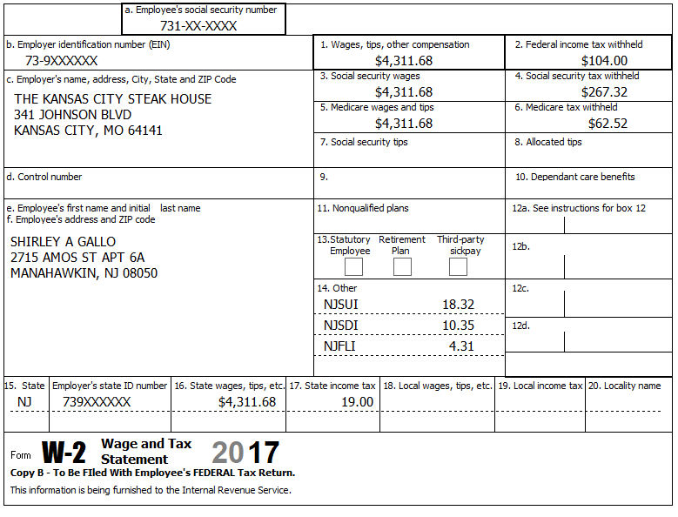

Federal AGI: 4,312 Federal Refund: 104 NJ Refund Amount: 19
Step 3 Interest 1099-INT
TP Form / Note | TS Screen | Notes
1099-INT  Big City Bank | Income  Interest and Dividends Form 1099-INT/ 1099-DIV- Begin  Interest or Dividend Income -Begin  Check Tax Exempt Interest Income, Form 1099-INT and 1099-DIV  Continue | Enter values that apply  Hint: Since the interest is tax exempt both Federal and State, there is no adjustment required for the State.  Continue -

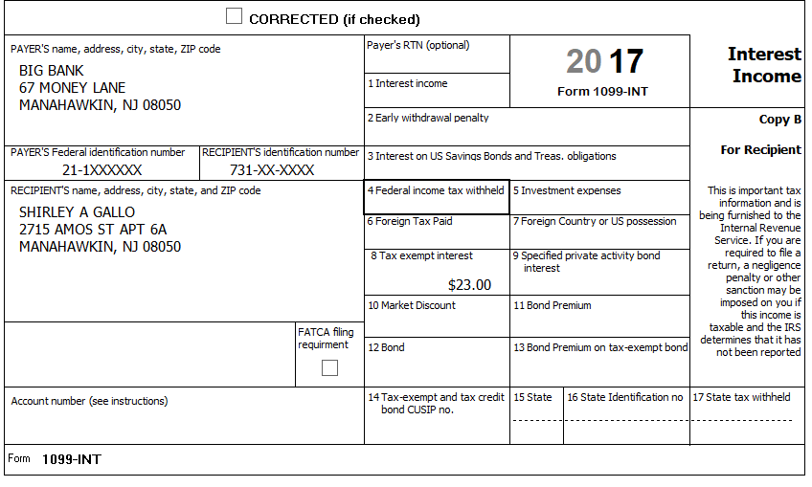

The tax exempt interest received was from a NJ Turnpike Bond and it is tax exempt in NJ.

Federal AGI: 4,312 Federal Refund: 104 NJ Refund Amount: 19
Step 4 Federal Deductions, Adjustments & Credits
TP Form / Note | TS Screen | Notes
 | Left Menu - Federal Section  Deductions  Enter Myself  Itemized Deductions  Taxes You Paid - Begin | TS: Go to the Add Sales Tax Worksheet and enter NJ, Zip Code, and 365 days living in the state  Continue back to Deductions

Federal AGI: 4,312 Federal Refund: 104 NJ Refund Amount: 19

Step 5 Compare Standard vs Itemized Deductions

TP Form / Note | TS Screen | Notes
 | Federal Section  Deductions  Enter Myself  Compare Deductions - Begin | Check to see if using itemized or standard deductions.  Itemized = 51  Std = 4,662  Hint: You can view Schedule A (Itemized Deductions) by clicking on the Print Icon next to Itemized Deductions in the Deductions Menu.  Continue

Federal AGI: 4,312 Federal Refund: 104 NJ Refund Amount: 19
Step 6 Health Insurance
TP Form / Note | TS Screen | Notes
G-Note 2 | Left Menu-Health Insurance  Start Questionnaire | Hint: Parents are responsible for her health insurance. Skip the Health Insurance Screen.

Shirley is totally supported by her parents and her parents will claim her as a dependent on their return.

Federal AGI: 4,312 Federal Refund: 104 NJ Refund Amount: 19
Step 7 New Jersey Return

TP Form / Note | TS Screen | Notes
I-Note 2,3  G-Note 2,3,4 | State Section –Edit  Basic Information | Hint: Use the NJ Checklist to enter NJ items  HINT: Check Basic Information  Hint: No other inputs are required for NJ. TP does not pay rent  Save back to the beginning of the State Return

Federal AGI: 4,312 Federal Refund: 104 NJ Refund Amount: 19

Step 8 Prepare for e-file

Intake Sheet  Supplemental Intake Sheet  G Note 5 | Left Menu – e-file – | TS – Clear up any diagnostic messages (if any)  TS: Select Federal Return Type “E:file: Paper Check”  Next  TS: No entries in Fees section except for Client email address  TS – Pin numbers for e-file are automatically selected  Next  TS: Select State Refund Type “E:file: Paper Check”  Next  TS: Skip Third Party Designee Info  Next  TS: Consent to Disclose  Select the DENY line  Enter Primary Pin for TP (any 5 digit number is OK)  Enter Primary Pin Date  Next  TS – Questions – Answer questions from Intake sheet Part VII, lines 5.6 and 7  Next  TS: Skip TP ID Information Screen  Save  You are Done

She wants to handle any state refund / amount due like their federal refund / amount due.

Federal AGI: 4,312 Federal Refund: 104 NJ Refund Amount: 19

